ERS DAY2 TRAINING
- c program without using printf
#include <stdio.h>
#include<unistd.h>

int main() {
puts("Embedded\n");

char str[] = "Welcome to C";
int i = 0;

while(str[i] != '\0') {
putchar(str[i]);
i++;
}
write(1, "Hello\n", 6);
}
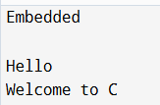
2.Read two integers

#include <stdio.h>

int main() {
int a=10;
int b=2;
int sum=a+b;
int di=a-b;
int c=a*b;
int d=a/b;
printf("sum=%d\n",sum);
printf("diff=%d\n",di);
printf("product=%d\n",c);
printf("quotient=%d\n",d);

}
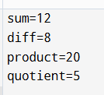
3.Temperature calculation
#include <stdio.h>

int main() {
float c,f;

printf("Enter temp: ");
scanf("%f", &c);

f= (c* 9 / 5) + 32;

printf("Fahrenheit = %.1f\n", f);

}
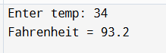
4.leap year
#include <stdio.h>

int main() {
int n;

printf("Enter: ");
scanf("%d", &n);

if( (n % 400 == 0) || (n % 4 == 0 && n % 100 != 0) ) {
printf("Leap Year\n") ;
}else{
printf("Not\n");
}
}
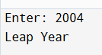
5.Character Type
#include <stdio.h>
#include <ctype.h>

int main() {
char c;

printf("Enter ");
scanf("%c", &c);

if (isalpha(c)) {
c= tolower(c);
if (c=='a' || c=='e' || c=='i' || c=='o' || c=='u')
printf("Vowel");
else
printf("Consonant");
}
else {
printf("Special Character");
}
}
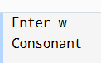
6.Swap two variables
#include <stdio.h>

int main() {
int a=5;
int b=2;
a=a+b;
b=a-b;
a=a-b;
printf("%d\n",a);
printf("%d\n",b);

}
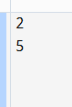
7.factorial
#include <stdio.h>

int main() {
int a=5;
int fact=1;

for(int i=1;i<=a;i++){
fact=fact*i;
}
printf("%d",fact);
}
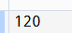
8.fibonacci series
#include <stdio.h>

int main(){
int a=2;
int b=3;
int c;
int n=5;
printf("%d\n",a);
printf("%d\n",b);
for(int i=1;i<n-1;i++){
c=a+b;
printf("%d\n",c);
a=b;
b=c;
}
}
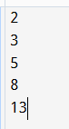
OR
#include <stdio.h>

int fib(int n) {
if (n == 0)
return 0;
else if (n == 1)
return 1;
else
return fib(n-1) + fib(n-2);
}

int main() {
int n=5;

printf("Fibonacci ");
for(int i = 0; i < n; i++) {
printf("%d ", fib(i));
}
return 0;
}

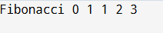
9.reverse integer

#include <stdio.h>

int main() {
int n=51;
int rev=0;
int rem;
while(n!=0){
rem=n%10;
rev=rev*10 +rem;
n=n/10;
}
printf("%d",rev);
}
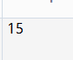
10.32 bit-check overflow condition
#include <stdio.h>
#include <limits.h>

int main() {
int x = INT_MAX; // 2147483647

printf("Before %d\n", x);

x = x + 1;

printf("overflow: %d\n", x);

return 0;
}
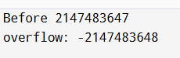
11.prime number
#include <stdio.h>

int main() {
int n=4;
int isprime=0;
if(n<=0){
isprime=0;

}else{
for(int i=2;i*i<n;i++){
if(n%i==0){
isprime=1;
break;
}
}
}
if(isprime){
printf("prime");
}else{
printf("not prime");
}
}
12.armstrong and perfect number
#include <stdio.h>
#include <math.h>

void arm(int n){
int count=0;
int temp;
int sum=0,digit;
temp=n;
while(temp!=0){

temp=temp/10;
count++;
}
temp=n;
while(temp!=0){
digit=temp%10;
sum += pow(digit,count);
temp=temp/10;

}
if(sum == n){
printf("Armstrong\n");
}
}
void perfect(int n){
int sum=0;
for(int i=1;i<=n/2;i++){
if(n%i==0){
sum=sum+i;
}
}
if(sum==n && sum!=0){
printf("perfect number\n ");
}
}

int main() {
int n=6;
perfect(n);
arm(n);
}
